American Cheese Month

SUNDAY, MAY 18, 2025


MONDAY, MAY 19, 2025

10:30am Bible Study with Frank Corona – Chapel

1:00pm Pet Visits with Koko

2:00pm Gospel Music w/ Good News Singers – Dining Room

TUESDAY, MAY 20, 2025

9:45am Exercise with Sue – 1000 Day Room

10:00am Tours of the CBRF – Meet in the 1000 Day Room

1:45pm Protestant Church Service – Dining Room
w/ Frank Corona


3:30pm Room Visits with Emily

WEDNESDAY, MAY 21, 2025

9:30am Pet Visits with Lily & Shep

10:00am Dice Game – 1000 Day Room

1:15pm Intergenerational Group w/ State Road 3rd Graders – Dining Room

3:00pm Pet Visits with Argos

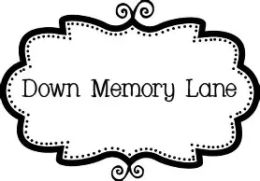
THURSDAY, MAY 22, 2025

9:45am Exercise with Emily – 1000 Day Room

10:15am Reminiscing with LaVerne & Angie – 1000 Day Room

2:00pm Word Service w/ Catholic Communion – Chapel

3:30pm Outdoor Visits – Out front


FRIDAY, MAY 23, 2025

10:00am Trivia Tournament to Rooms
Weekly calendars delivered

2:00pm Bingo – 1000 Day Room

SATURDAY, MAY 24, 2025

Sign-ups start Tuesday, May 27th
at 10:30am on clipboards outside Recreation Room
(no early sign-ups taken)

June 5th – Pontoon Boat Ride - Free

Menu Week 3

