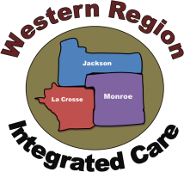 | MEETING AGENDA
MEETING:
CCS Vendor Conference
 | PURPOSE: Specific CCS related updates to all vendors
Meeting Date | Location(s) | Start Time |  | End Time | Call-In #
03/14/22 | Microsoft Teams
Facilitator/Lead | Materials/Preparation Required
CCS Supervisors
Agenda Items |  |  | Outcome/Notes
Administrative
- Notes, Billing Invoices, & Payment
  - New Invoice Requirement: Location Codes
  - Non-Billable Notes
  - Clean Claim Payment protocols for QA/Fiscal in Processing Vendor Billing
- Review of “Medical Necessity” within CCS Services
- Copies of Current Licensure and Credentials
  - Service array categories that require copies of professional licensure and/or credentials to be submitted prior to billing to Medicaid
- Notification Process for Program or Staff Changes

Data Trends & Impact
- Summary overview of 2022 data outcomes, and program trends

Program Development
- Vendor Sharepoint Site (launching in April)
  - Centralized library for program information, documents/templates, training resources
  - Demonstration
  - Access process

Questions?
Walk-On Items:

